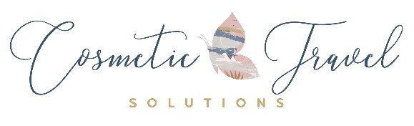
Request for Quote – Cosmetic Surgery

Name:

Address:

Contact Number:

Email Address:

Surgeries you are considering:

Age and Date of Birth:

Height:

Weight:

Past surgeries and dates:

Did you have any complications from the surgeries or anesthetic? If so, please provide more detail:

List any past or present serious illnesses and/or medical conditions:

Females Only: Have you had any pregnancies? If yes, how many and were the births natural or C-section?

Current medications both Rx and over the counter:

Do you have any allergies both medication and environment, if yes, list:

Do you smoke or vape? If yes how many per day on average?

Do you use any recreational drugs? If yes, what and how often?

Do you drink alcoholic beverages? If yes, what and how often?

Month and year, you are hoping to have surgery?

I would like a quote from Dominican, Mexico, or both locations:

Do you give consent to add your email address to our data base for the sole purpose of sharing upcoming special offers and promotions?

Your information is kept strictly private and confidential and will not be shared with any third-party sources.

Please submit photos and completed form to Jen at jen@cosmetictravelsolutions.com

